Forex Analysis

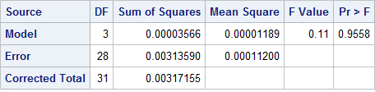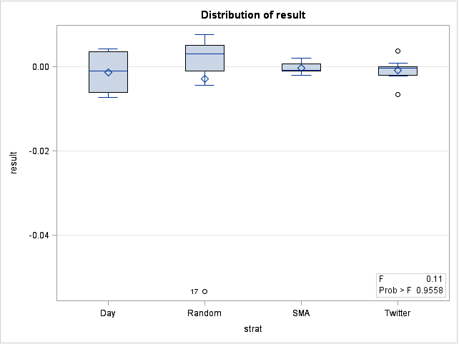First I ran a simple ANOVA using the P/L numbers from the trading rules. Unfortunately with just those there didn’t appear to be any difference

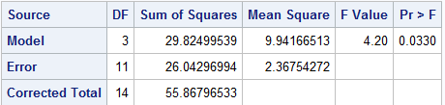I decided to see what would happen if I tried a log transformation on the data and re-ran the ANOVA. This time we do reject the null hypothesis. The other benefit is that the heavy skew in random goes away (although SMA does take on some positive skew).

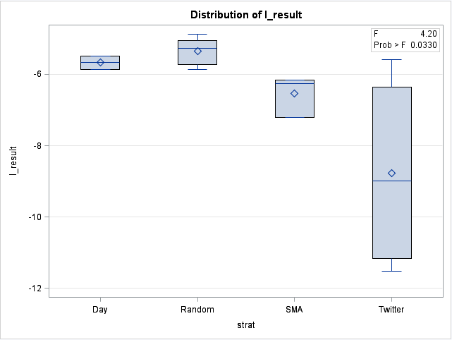

Just looking at the box plot it seems that Random is the best with Twitter has a wide range of results and tends to perform the worse.

I then ran Dunnetts to compare them all to random, as well as Scheffe’s multiple comparison, and the more conservative Bonferroni. Compared to random, only twitter was significantly different. The results from the Scheffe/Bonferroni were the same; the only pairwise comparison that differed was random and twitter. Given the data we have we can conclude that the random outperforms twitter but not the others. There also seems to be no difference between Twitter and the SMA or Day strategy. All of them come close to outperforming twitter but aren’t significant at 0.05. I did try bringing alpha all the way up to 0.25 but even by then there were no significant differences except the day strategy started to outperform twitter (even at alpha = 0.4 none of them were different than random but all outperformed twitter)

